

UNDERGRADUATE PROJECT PROPOSAL

|  |  |
| --- | --- |
| **Project Title:** | **Federated** **Convolutional Generative Network for Next Item Recommendation** |
| **Surname:** | **Long** |
| **First Name:** | **Yicheng(Jack)** |
| **Student Number:** | **202018010116** |
| **Supervisor Name:** | **Joojo Walker** |
| **Module Code:** | **CHC 6096** |
| **Module Name:** | **Project** |
| **Date Submitted:** | **2023.11.3** |

**Table of Contents**

1 Introduction 3

1.1 Background 3

1.2 Aim 3

1.3 Objectives 3

1.4 Project Overview 4

1.4.1 Scope 4

1.4.2 Audience 4

2 Background Review 5

3 Methodology 6

3.1 Approach 6

3.1.1 Federated Learning Recommendation System 6

3.1.2 A Convolutional Generation Model for Item Recommendation Based on Conversation 7

3.2 Technology 8

3.3 Version management plan 8

4 Project Management 8

4.1 Activities 8

4.2 Schedule 10

4.3 Data management plan 10

4.4 Project Deliverables 11

5 References 12

# Introduction

## Background

In recent years, in the field of recommendation systems, the Next Item Recommendation System has gained increasing attention due to its ability to infer dynamic user preferences through sequential user interactions, as well as its real-time and personalized advantages. Especially in applications that focus on real-time or continuous user experiences, the Next Item Recommendation System has become very popular. For example, users of Last.fm or Weishi typically enjoy a series of songs/videos over a period of time [1]. Convolutional neural network (CNN), as a deep learning neural network architecture, has excellent feature extraction ability and sequence data processing performance. Therefore, the application of CNN in recommendation systems is very common. In addition, federated learning, as a decentralized machine learning method, allows models to be trained on local devices in recommendation systems, thereby protecting user data privacy and reducing data transportation costs. It is now widely used in recommendation systems.

## Aim

This project is the next recommendation system based on federated learning and convolutional generative networks. This system solves the user data privacy and data transmission cost issues of traditional recommendation systems by introducing federated learning, and processes data by introducing convolutional generation networks. Finally, a recommendation system that combines the above advantages can surpass existing recommendation systems to achieve better recommendation results.

## Objectives

• Collection of relevant literature

• Evaluation and Comparison of Models

Evaluate and compare the advantages and disadvantages of different federated learning recommendation systems and the next recommendation model based on CNN.

• Improved model

Propose an improvement to the existing next recommendation model based on CNN, introducing federated learning to the recommendation model.

• Selection and Preprocessing of Datasets

Select a suitable dataset from public resources and preprocess the data to meet the input requirements of the model.

• Implementation of the model

Implement a federated learning framework through programming, based on the next recommendation model of CNN, and then combine them.

• Experimental testing and optimization

Use the dataset as input to the recommendation system, conduct repeated testing, and adjust parameters and models according to different situations.

• Analysis and Summary

Analyze and summarize the experimental results, evaluate the performance of the recommendation system, including advantages and disadvantages, and complete the paperwork.

• Presentation Prepare

Create PowerPoint presentations, demonstrate videos, and prepare speeches.

## Project Overview

### Scope

The purpose of the study is to improve the next recommendation system by introducing a federated convolutional generation network model to overcome the shortcomings of traditional CNN recommendation systems. This model aims to better capture the features and sequential patterns in user project interaction sequences, thereby providing more personalized and accurate recommendations. Regarding importance, it has technological innovation and addresses the shortcomings of traditional methods. It also has significant importance for practical applications, improving user experience and having a positive impact in commercial applications.

### Audience

Users and producers of products that require real-time recommendations will be one of the main beneficiaries, such as applications in music streaming, video on demand, e-commerce, online games, and other fields. For their product users, the Next Item Recommendation System will provide more personalized and real-time recommendations that users are interested in, making it easier for product users to find products, services, or information of interest, This saves time and effort, and product developers gain more users as a result. In addition, some companies or advertisers are the main beneficiaries. By increasing transaction volume, businesses can benefit, and advertisers can place more targeted advertisements to improve advertising efficiency. Technical researchers will also benefit from new technologies and methods.

# Background Review

The earliest work and ideas for sequence recommendation mainly relied on Markov chains [2] and feature based matrix decomposition [3] methods. Markov chains are a mathematical model in which the occurrence of an event only depends on the state of the previous event, and is independent of the earlier state. But it also has some shortcomings, especially when dealing with complex sequence data, its ability to model complex nonlinear relationships and patterns in sequence data is limited and lacks long-term memory. Afterwards, deep learning models gradually began to demonstrate advanced recommendation accuracy. In 2016, Hidasi et al. [4] proposed a DL based SBR system, commonly known as GRU4Rec. This is the first model to use RNN, which introduces session parallel small batch, output sampling based on small batch, and sorting loss function, resulting in significant results due to popular baselines. In 2018, Tang and Wang [5] proposed a new sequence recommendation called Caser. They abandoned the RNN structure and proposed a convolutional sequence embedding model, demonstrating that this CNN based recommendation can achieve similar or superior performance in the popular RNN model's top-N sequence recommendation. Not long after the same year, Yuan et al. [1] proposed a simple, efficient, and efficient convolutional generation model for session based top-N project recommendations. This model is suitable for short-term and long-term project dependencies and simplifies deeper network optimization. Ultimately, the model's recommendation accuracy and effectiveness are significantly better than existing technologies at the time. In 2021, Song et al. [6] designed an effective SBRS called Intersessional Collaborative Recommendation Network (Insert) to recommend the next project in short sessions, and designed a Session Retrieval Network (SSRN) to identify sessions similar to the current short session from the historical sessions of the current user and other users, resulting in better recommendation performance than the most advanced series of recommendations at the time. In the same year, Chai et al. [7] proposed a secure matrix decomposition framework under federated learning settings, called FedMF, which to some extent prevents users' raw data leakage and ensures user data privacy, but has not been applied in recommendation systems. In 2023, Li et al. [8] proposed Federated Recommendation with Additive Personalization (FedRAP), which introduced federated learning. This recommendation system effectively avoids user information leakage, reduces communication costs, and solves the problem of poor personalization in other federated recommendations. Afterwards, Kumar et al. [9] proposed a Horizontal Vertical Convolutional Neural Network (HV-CNN) embedded with Word2Vec technology, which outperformed state-of-the-art methods on 30 publicly available music datasets.

# Methodology

## Approach

## 3.1.1 Federated Learning Recommendation System

Federated learning is a privacy preserving distributed learning scheme proposed by Google, which allows machine learning models to use intermediate model parameters for training, avoiding direct use of user real data and thus protecting user privacy. Due to the fact that traditional recommendation systems typically store user data centrally on a server and use it directly for training and testing, introducing federated learning into recommendation systems can effectively protect user privacy data. In this article, we refer to it as the Federated Recommendation System (FedRS). FedRS uses a federated learning architecture based on local storage of participant data, as shown in Figure 1. Its communication architecture can be divided into client server architecture and peer architecture. The client server architecture relies on a central server to perform initialization and model aggregation tasks. The server is responsible for distributing the global recommendation model to selected clients, and then the clients use the received model and local data for local training in each round. Finally, the client sends the updated intermediate parameters (such as model parameters and gradients) back to the server for global model aggregation. The peer-to-peer architecture does not have a central server participating in the communication process. In each round of communication, each participant broadcasts the updated intermediate parameters to some random online neighbors, and then aggregates the received parameters into their own global model. This architecture can avoid single point of failure issues and privacy issues related to central servers.

Figure 1: Communication architecture of FedRS

## 3.1.2 A Convolutional Generation Model for Item Recommendation Based on Conversation

This model directly processes the sequence of items that have been previously interacted with. Its goal is to estimate the distribution of the original item interaction sequence in order to reliably calculate the probability of the item and generate future items that users may enjoy interacting with. The model introduces a probability distribution p (x), which represents the joint distribution of item sequence x={x0,..., xt}. To model p (x), the chain rule can be used to decompose it into a product of a series of conditional distributions, taking into account the probability distribution of each item, as shown in Figure 2:

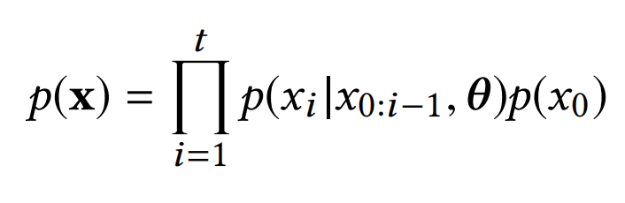

Figure 2: Conditional probability of an item

Next, K proposes to use an extended 1D convolutional neural network (CNN) to model the conditional distribution of user item interaction, as shown in Figure 3 (b). Compared with the standard CNN (Figure 3 (a)), the extended convolutional neural network uses the convolutional operation of "l-dialated convolution" to obtain a larger receptive field without introducing more parameters. This enables the network to better capture long-range dependencies in input data.

Figure 3: Conditional distribution prediction

## Technology

Hardware includes: computer (GPU: NVIDIA RTX2070S, RAM: 500G), software includes: deep learning framework: TensorFlow, programming language: Python 3.9, editor: PyCharm3.3, data preprocessing tool: MySQL.

## Version management plan

Use the Git repository and Feishu to manage project code or multiple versions of models that have been developed. The code will continue to be updated on Github's personal homepage, and backup management will also be carried out every time it is submitted through Flybook to facilitate subsequent changes.

# Project Management

## Activities

|  |  |
| --- | --- |
| **Objectives** | **Tasks** |
| Collection of relevant literature | Read at least 20 articles in relevant fields, select and take notes |
| Project Proposal | Complete the proposal with clear structure and logic, including a reference list |
| Understanding models and mathematical methods | Analyze and compare the differences between models and interpret relevant methods |
| Improved model | According to the shortcomings of the existing model, search for possible improved technologies and methods through the literature |
| Experimental data processing | According to relevant research fields, the data set was searched and preprocessed |
| Experiment and Test | The model was implemented by code and applied to the dataset, trial and error |
| Summary | Analyze and summarize the experimental results to reach a conclusion, and complete the remaining writing |
| Paper Modify | Revise the format and improve the article |
| Presentation Prepare | Prepare PPT and review research work |

## Schedule

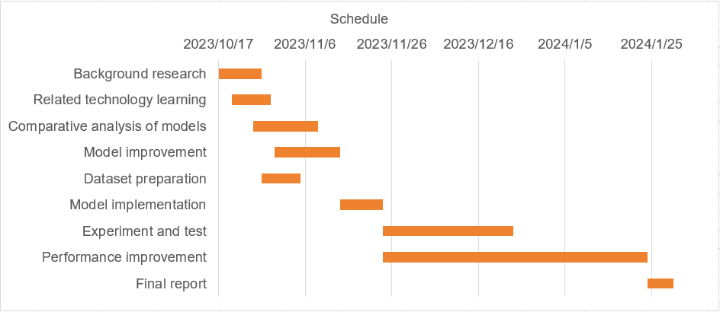

**Table 1: Gantt chart of thesis plan**

## Data management plan

This article uses Zotero to manage relevant literature, including storing the literature in the Zotero manager and annotating and taking notes on each literature, making it easy to quickly search for the desired literature. For code files and dataset files, the code files will be uploaded to a personal account through Github for backup, and each version and date will be classified. Finally, regarding report file management, literature will be stored in cloud documents through the use of WPS office.

|  |  |
| --- | --- |
| Literature management | Zotero |
| Code management | Github |
| Report management | WPS office |

Table 2: Management

## Project Deliverables

|  |  |
| --- | --- |
| Project Resources | Deadline |
| weekly reports | Every week from the fourth week of the first semester |
| Project proposal, ethic form, plagiarism report | November 3, 2023 |
| Progress Report | December 22, 2023 |
| final report | April 12, 2024 |
| presentation poster, video, and demo | May 29th to 31st, 2024 |
| Tech Show | June 6th -7th, 2024 |

Table 3: Resources and Submission Date

# References

[1] F. Yuan, A. Karatzoglou, I. Arapakis, J. M. Jose, and X. He, ‘A Simple Convolutional Generative Network for Next Item Recommendation’. arXiv, Nov. 28, 2018. Accessed: Oct. 27, 2023. [Online]. Available: http://arxiv.org/abs/1808.05163

[2] C. Cheng, H. Yang, M. R. Lyu, and I. King, ‘Where You Like to Go Next: Successive Point-of-Interest Recommendation’.

[3] X. He and T.-S. Chua, ‘Neural Factorization Machines for Sparse Predictive Analytics’. arXiv, Aug. 16, 2017. Accessed: Oct. 27, 2023. [Online]. Available: http://arxiv.org/abs/1708.05027

[4] B. Hidasi, A. Karatzoglou, L. Baltrunas, and D. Tikk, ‘Session-based Recommendations with Recurrent Neural Networks’. arXiv, Mar. 29, 2016. Accessed: Oct. 27, 2023. [Online]. Available: http://arxiv.org/abs/1511.06939

[5] J. Tang and K. Wang, ‘Personalized Top-N Sequential Recommendation via Convolutional Sequence Embedding’. arXiv, Sep. 19, 2018. Accessed: Oct. 27, 2023. [Online]. Available: http://arxiv.org/abs/1809.07426

[6] W. Song, S. Wang, Y. Wang, and S. Wang, ‘Next-item Recommendations in Short Sessions’. arXiv, Jul. 20, 2021. doi: 10.48550/arXiv.2107.07453.

[7] D. Chai, L. Wang, K. Chen, and Q. Yang, ‘Secure Federated Matrix Factorization’, *IEEE Intell. Syst.*, vol. 36, no. 5, pp. 11–20, Sep. 2021, doi: 10.1109/MIS.2020.3014880.

[8] Z. Li, G. Long, and T. Zhou, ‘Federated Recommendation with Additive Personalization’. arXiv, May 17, 2023. doi: 10.48550/arXiv.2301.09109.

[9] C. Kumar and M. Kumar, ‘Next-item recommendation within a short session using the combined features of horizontal and vertical convolutional neural network’, *Multimed. Tools Appl.*, 2023, doi: 10.1007/s11042-023-17201-z.